

**STUDENT INTERNSHIP PROGRAM**

**(SIP) REPORT**

**SUBMITTED TO**

**MIT ACADEMY OF ENGINERRING**





**SUBMITTED BY -**

**Nikita Nandkumar Burgute**

**Roll No. – 67**

**PRN - 202301040057**



**SCHOOL OF COMPUTER ENGINEERING AND TECHNOLOGY**

**MIT ACADEMY OF ENGINERRING,ALANDI(PUNE)**

**CERTIFICATE**

This is to certify that the “Student Internship Program (SIP)” report submitted by Nikita Nandkumar Burgute, PRN- 202301040057 is work done by her and is submitted during the 23-24 academic year.

**Faculty Mentor H.O.D**

Ms.Prajakta Dashrath Dr.Pramod.D.Ganjewar

**School Dean**

Dr.Rajeshwari M. Gaudar



**DECLARATION**

I, Nikita Nandkumar Burgute, hereby declare that I have successfully completed four specialized courses during my internship. These courses were conducted by Infosys Springboard and EXCELR, with a total duration of one month and a cumulative learning time exceeding 120 hours. The details of the courses are outlined below:

1. **Introduction to Python** (Infosys Springboard)
2. **EXCELR Course on Digital Marketing** (EXCELR)
3. **Java Fundamental Course** (Infosys Springboard)
4. **Basic Course on Advanced C#** (Infosys Springboard)

I have gained valuable knowledge and skills in programming and digital marketing through these courses. The certificates I received reflect my commitment to learning and improving professionally. This statement is made honestly for review purposes.

Date: [30/09/2024]  
Location: [Pune]  
[Name : Nikita Nandkumar Burgute]  
[Contact : 8767961354]



**ABSTRACT**

This report presents a reflection on the four specialized courses I completed during my internship, which collectively helped me develop both technical and strategic skills. The overall duration of the courses was one month, with a total learning time exceeding 120 hours. These courses combined theoretical knowledge with practical, hands-on experience, ensuring a well-rounded learning process.

The second course, the EXCELR Course on Digital Marketing, taught me about modern digital marketing strategies. I learned about SEO, SEM, content marketing, and social media management.

The third course, Java Fundamental Course, focused on object-oriented programming (OOP). It strengthened my understanding of key programming concepts like classes, inheritance, polymorphism, and exception handling.

The fourth course, Basic Course on Advanced C#, introduced me to higher-level programming concepts. It covered topics like multithreading and improved my understanding of software architecture and design.

This report outlines the key lessons and skills from each course, showing how these experiences have enhanced my ability to contribute to both technical and strategic projects. With a combination of programming knowledge and digital marketing skills, I am better prepared for a dynamic work environment.

**IV**



**ACKNOWLEDGMENT**

I would like to express my sincere gratitude for the opportunity to take part in these specialized online courses during my internship, which have greatly enhanced my learning experience. I would like to acknowledge the following institutions for their valuable contributions:

1. **Infosys Springboard**: I am thankful for the comprehensive and well-structured online curriculum offered in the *Introduction to Python*, *Java Fundamental Course*, and *Basic Course on Advanced C#*. The course materials and self-paced learning modules provided clear and detailed explanations, allowing me to build a solid foundation in programming concepts such as object-oriented programming, exception handling, and multithreading.
2. **EXCELR**: I deeply appreciate the *ExerR Course on Digital Marketing*, which provided valuable insights into key areas like SEO, SEM, content marketing, and social media management. This online course has equipped me with the skills necessary to navigate the dynamic world of digital marketing and apply these strategies effectively in professional environments.
3. **Advanced C# Course (Infosys Springboard)**: This course allowed me to explore advanced topics in C# programming through a practical, self-paced learning experience. It covered complex areas like multithreading, design patterns, and software development best practices, enhancing my technical understanding and preparing me for future software development projects.
4. **Data Analysis with Python (EXCELR)**: This course introduced me to data manipulation and analysis using Python libraries such as Pandas and NumPy. The hands-on exercises helped me apply theoretical knowledge to real-world data, a critical skill in today’s data-driven landscape.

#### V

#### 

#### INDEX

1) CERTIFICATE OF COMPLETION 1

2) INTRODUCTION 4

3) DETAILS 5

4) BREIFING OF WORK DONE 6

5) SCRENSHOTS OF WORK DONE 8

6) ASSIGNMENTS SUBMISSION 11

7) SCORE 16

8) PERFORMANCE 16

9) REFERENCES 17

10) PLAGIARISM REPORT………………………………………………………………………..18

**VI**



# 

# CERTIFICATE OF COMPLETION

**1.INTRODUCTION TO PYTHON :**

**CERTIFICATE:**

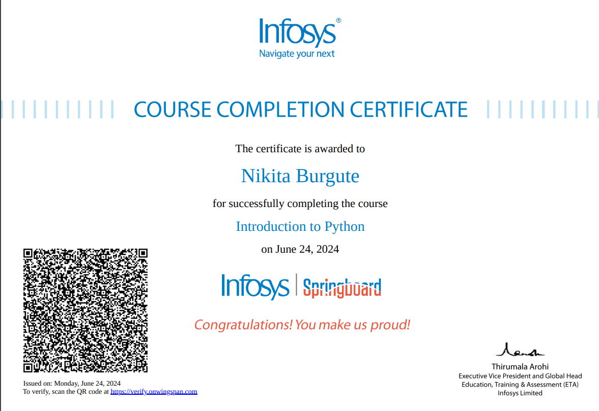

**1**



**2.EXCELR :**

**CERTIFICATE :**

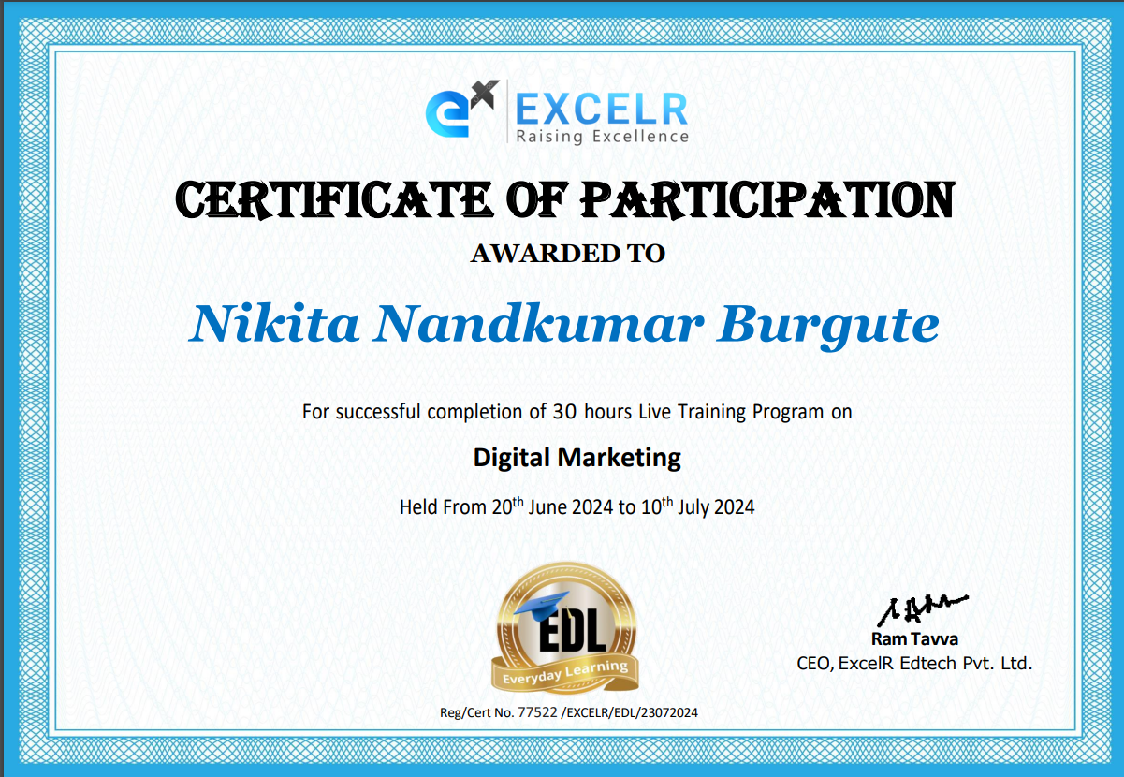

3.JAVA FUNDAMENTAL PROGRAMMING :

**CERTIFICATE:**

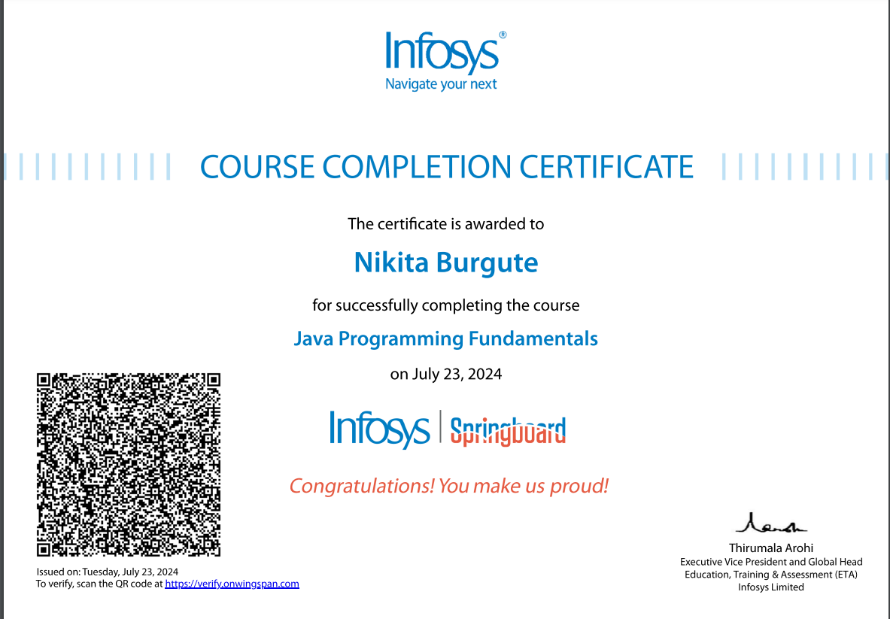

2



**4.ADVANCED CSHARP**

**CERTIFICATE:**

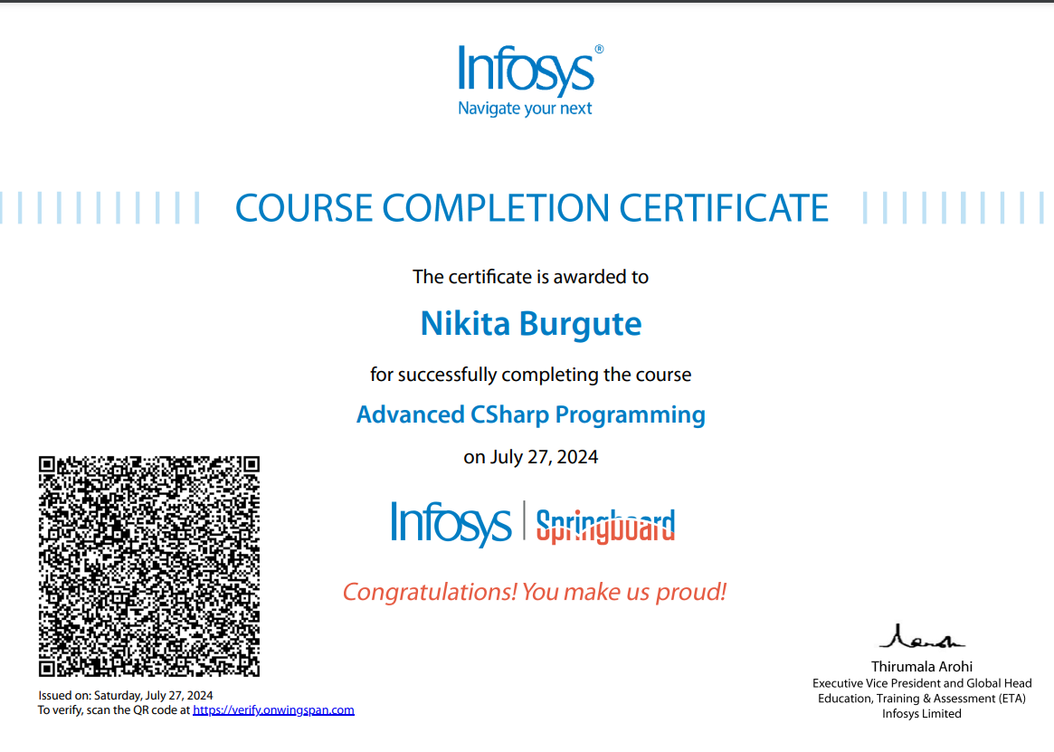

#### 3

#### 

#### INTRODUCTION

In today’s rapidly changing technological landscape, continuous learning and upskilling are crucial for staying competitive in any career. During my internship, I completed four specialized courses, each spanning two months and totaling 120 hours of comprehensive learning. These courses provided both theoretical foundations and hands-on practical experience.

1. **Introduction to Python**: This course introduced me to Python, one of the most versatile programming languages. I gained foundational skills in coding and problem-solving, which are essential for various applications.
2. **ExerR Course on Digital Marketing**: This course equipped me with key strategies in digital marketing, including SEO, SEM, and analytics. These skills are vital for businesses to thrive in the digital age.
3. **Java Fundamental Course**: This course focused on object-oriented programming (OOP) using Java, enhancing my understanding of essential concepts like classes, inheritance, and polymorphism, which are important for developing scalable software.
4. **Basic Course on Advanced C#**: This course allowed me to explore advanced C# programming concepts, such as multithreading and LINQ. I learned modern software development practices that are valuable in real-world applications.

Overall, these courses have helped me build a diverse skill set in both programming and digital marketing. In the following sections, I will detail each course, highlighting key focus areas and the specific skills I gained. This experience has significantly prepared me for the challenges of the professional wo

**4**



**DETAILS**

1. **Infosys Springboard Platform**

**Overview**:  
Infosys Springboard is an initiative by Infosys designed to equip learners with essential skills for the digital world. **Key Features**:

* **Comprehensive Curriculum**: Structured learning paths in multiple fields.
* **Hands-On Projects**: Encourages applying concepts through real-world projects.
* **Expert Instructors**: Courses created and taught by industry professionals.
* **Certification**: Recognized certificates upon course completion to validate skills.

**2. Exel-R Platform**

**Overview**:  
Exel-R is an educational platform focused on providing training in digital marketing, data analysis, and emerging technologies. **Key Features**:

* **Industry-Relevant Content**: Courses designed to meet current industry standards and practices.
* **Practical Learning**: Focus on hands-on training and case studies to enhance understanding.
* **Experienced Trainers**: Courses taught by professionals with significant industry experience.

**5**

Bottom of Form



**BRIEFING OF WORK DONE**

During my internship, I successfully completed four specialized courses that significantly enhanced my skills in programming and digital marketing. Here’s a summary of the work accomplished:

1. **Course Completion:**
   * Introduction to Python: Developed foundational coding skills and problem-solving abilities by learning Python programming, including data types, control structures, functions.
   * ExerR Course on Digital Marketing: Gained insights into digital marketing strategies, focusing on SEO, SEM, content marketing,
   * Java Fundamental Course: Strengthened my understanding of object-oriented programming (OOP) through Java, covering key concepts such as classes, inheritance, polymorphism, and exception handling.
   * Basic Course on Advanced C#: Explored advanced programming concepts in C#, including multithreading and LINQ, enhancing my knowledge of modern software development practices.
2. **Assessments and Quizzes:**
   * Completed various quizzes and assessments throughout each course to evaluate my understanding of the material.
   * Engaged in hands-on projects and case studies that reinforced learning and demonstrated the application of skills.

**6**



**3.Skill Development:**

* + Acquired a diverse skill set that combines programming proficiency with digital marketing knowledge, preparing me for various challenges in the professional world.
  + Developed a mindset of continuous learning and adaptability, essential for navigating the evolving job market.

**4.Certification:**

Earned recognized certificates for each course, validating my skills and knowledge in both technical and strategic domains.This work experience has broadened my technical capabilities and equipped me with the necessary tools to succeed in my future career endeavors.

**7**



**WORK DONE**

**Quizes :**

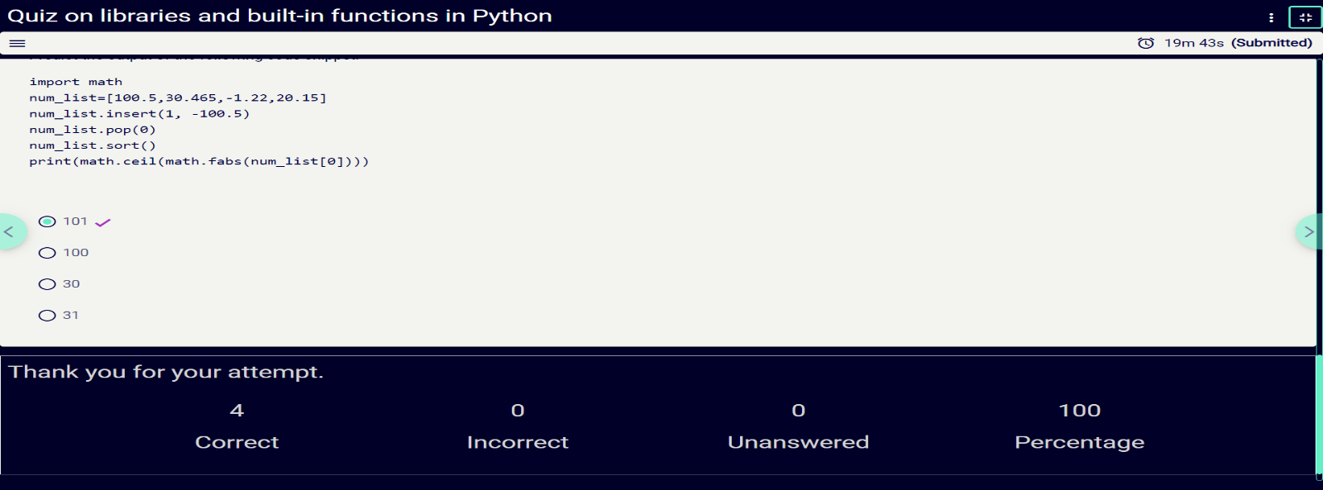

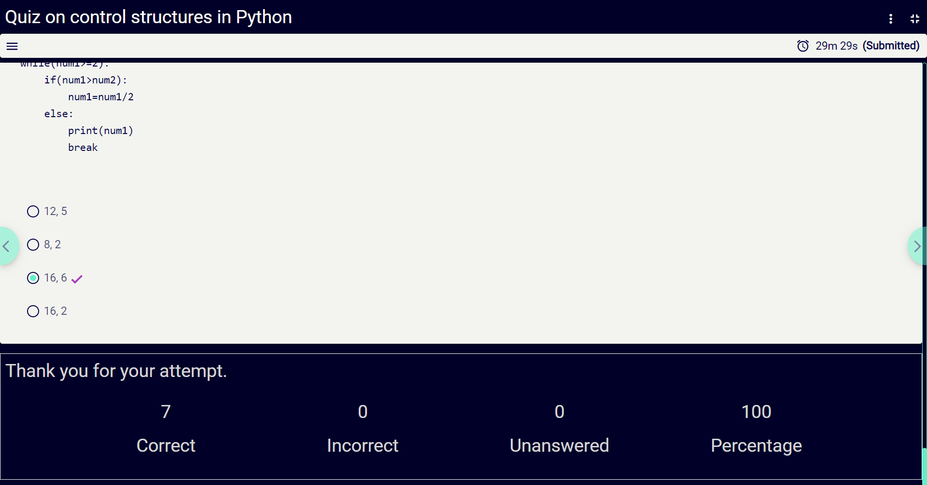

**8**





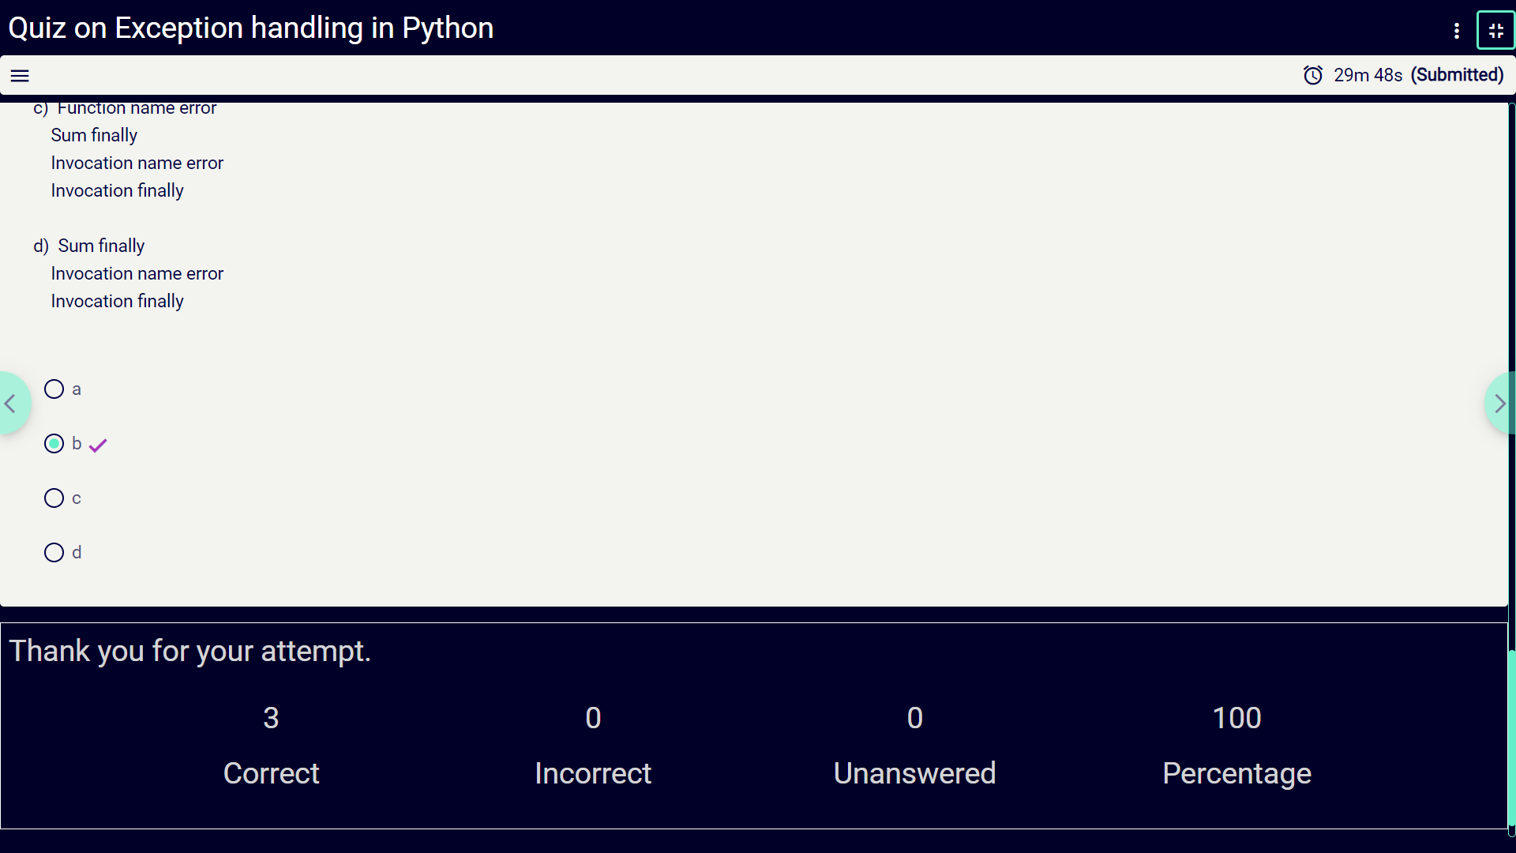

**9**



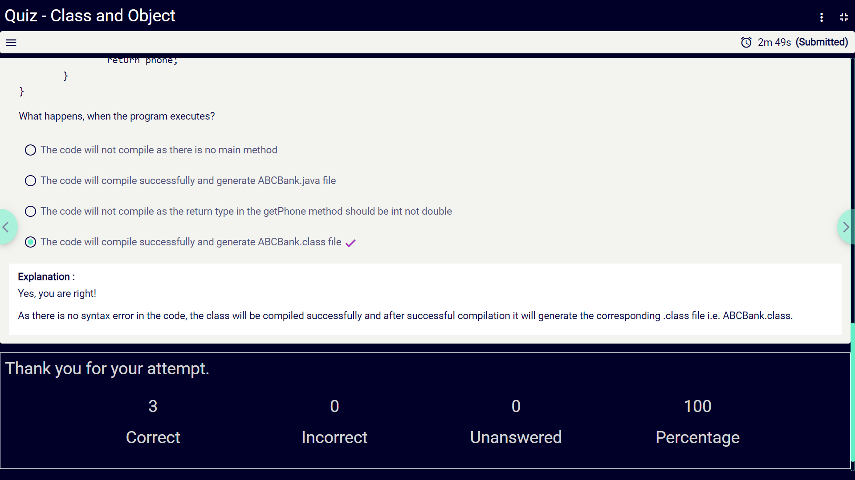

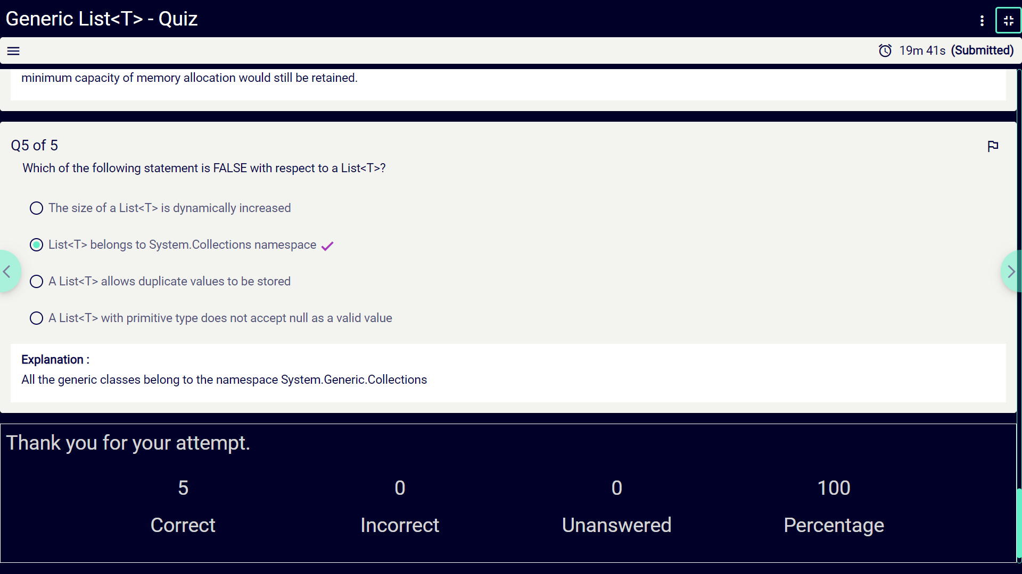

**10**



**Assignment :**

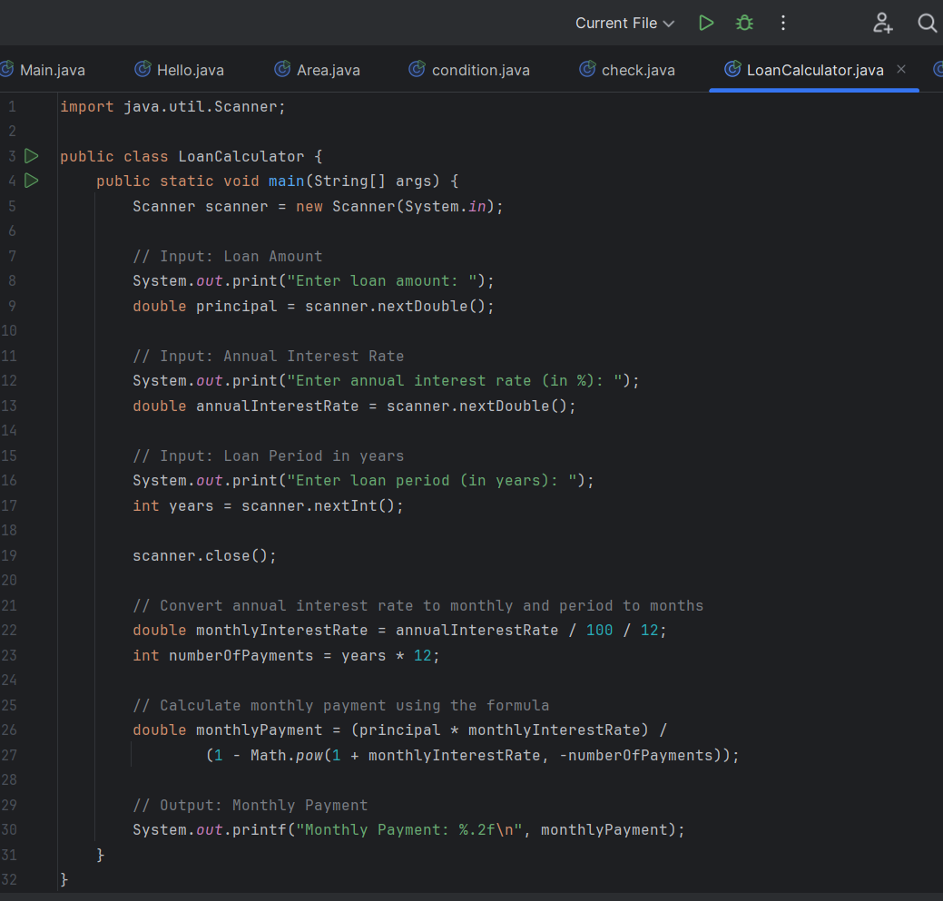

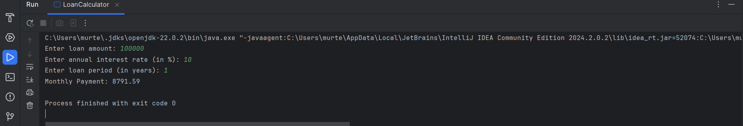

**11**



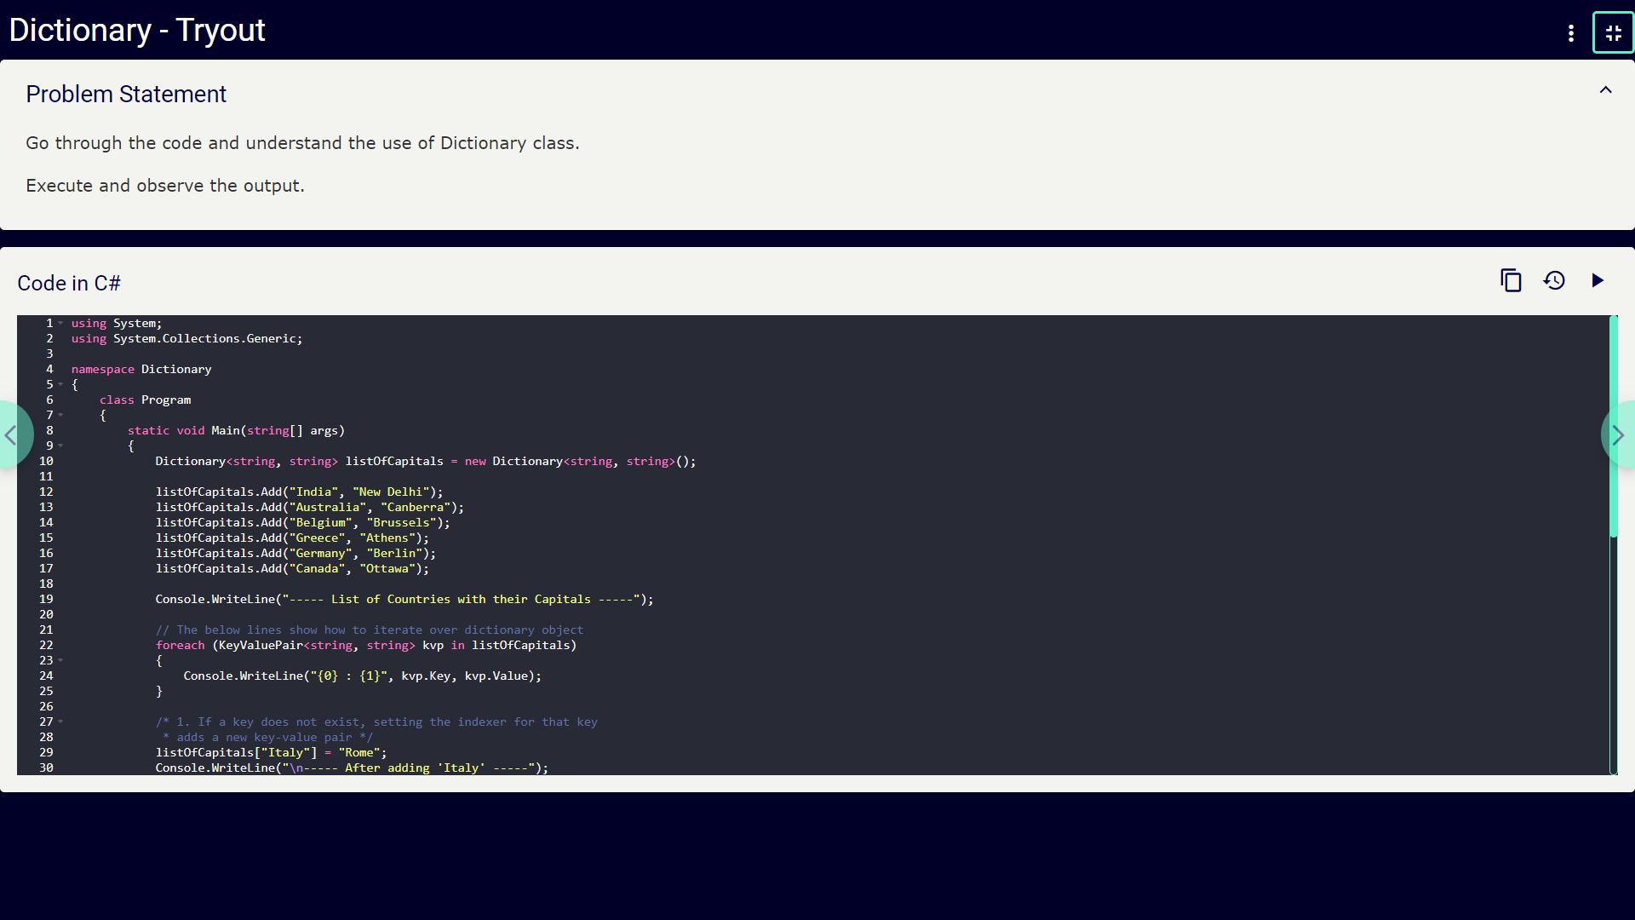

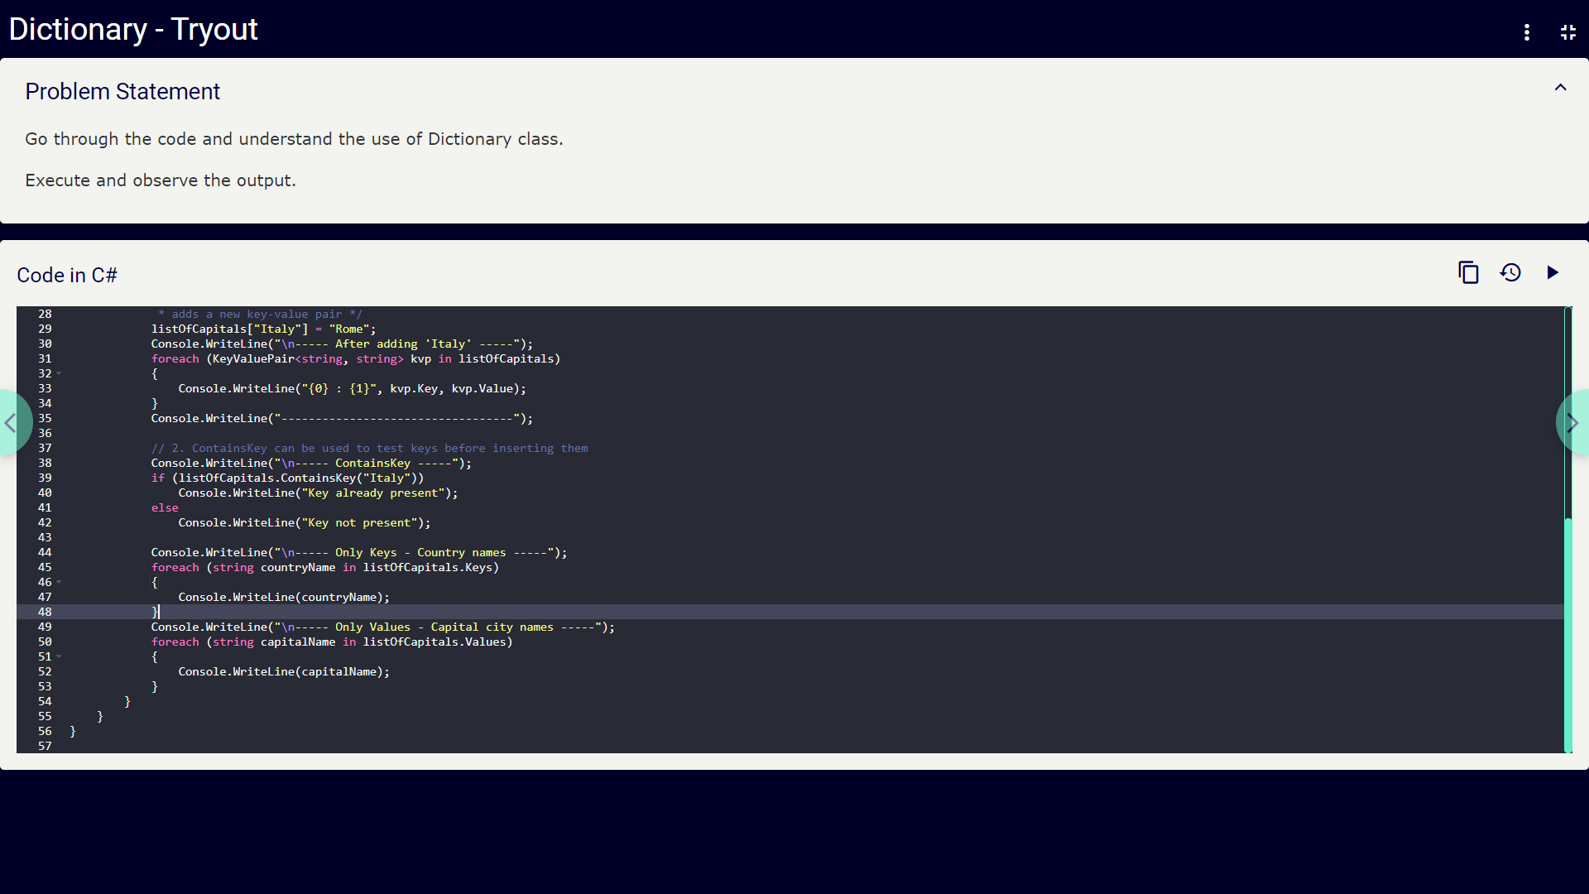

**12**



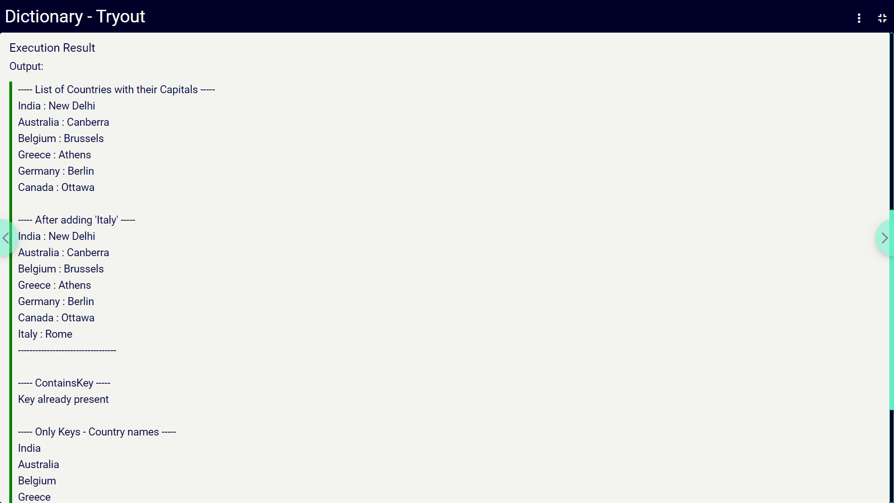

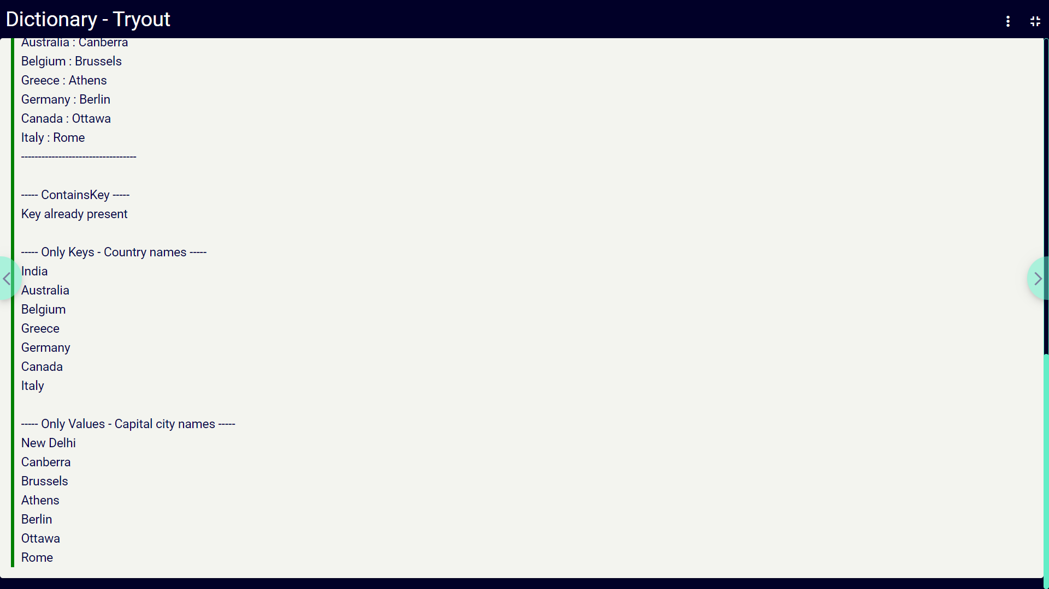

**13**



**SCREENSHOTS OF WORKDONE**

**1.INTRODUCTION TO PYTHON:**

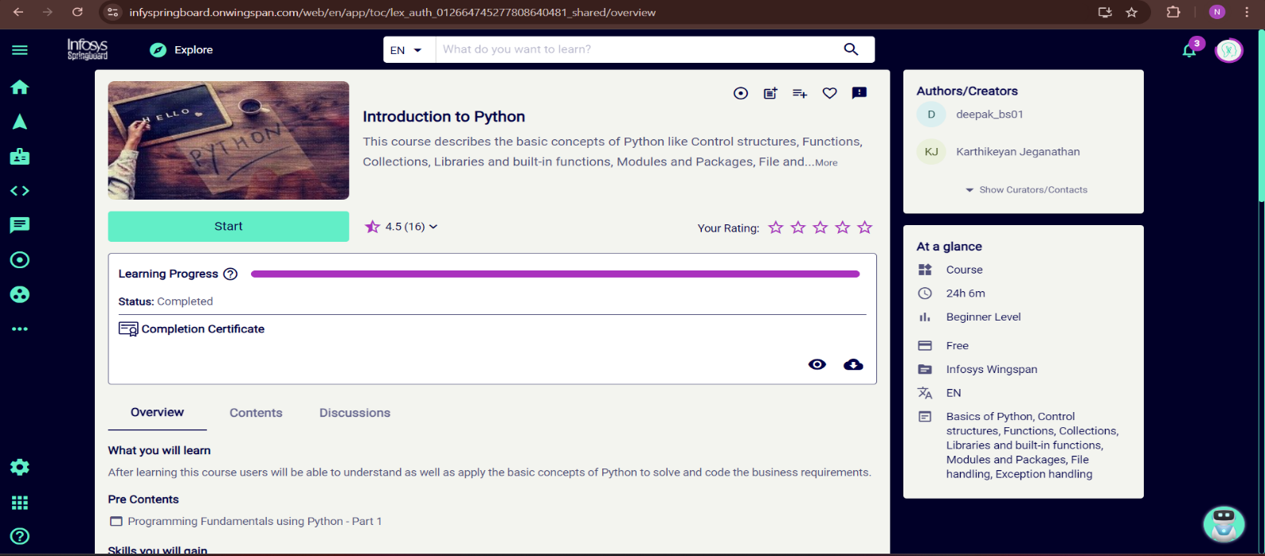

**2.EXCEL-R:**



**14**



**3.JAVA FUNDAMENTAL PROGRAMMING:**

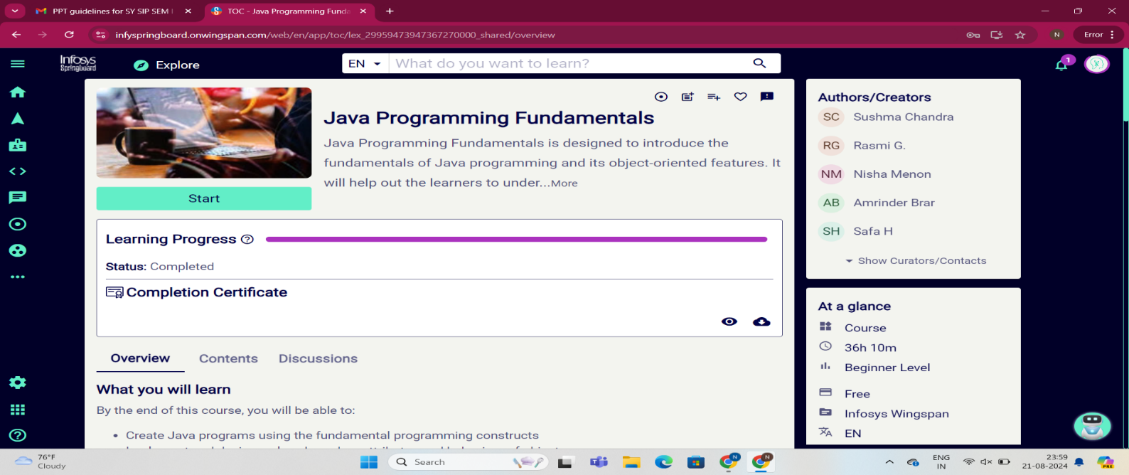

**4.ADVANCED CSHARP:**

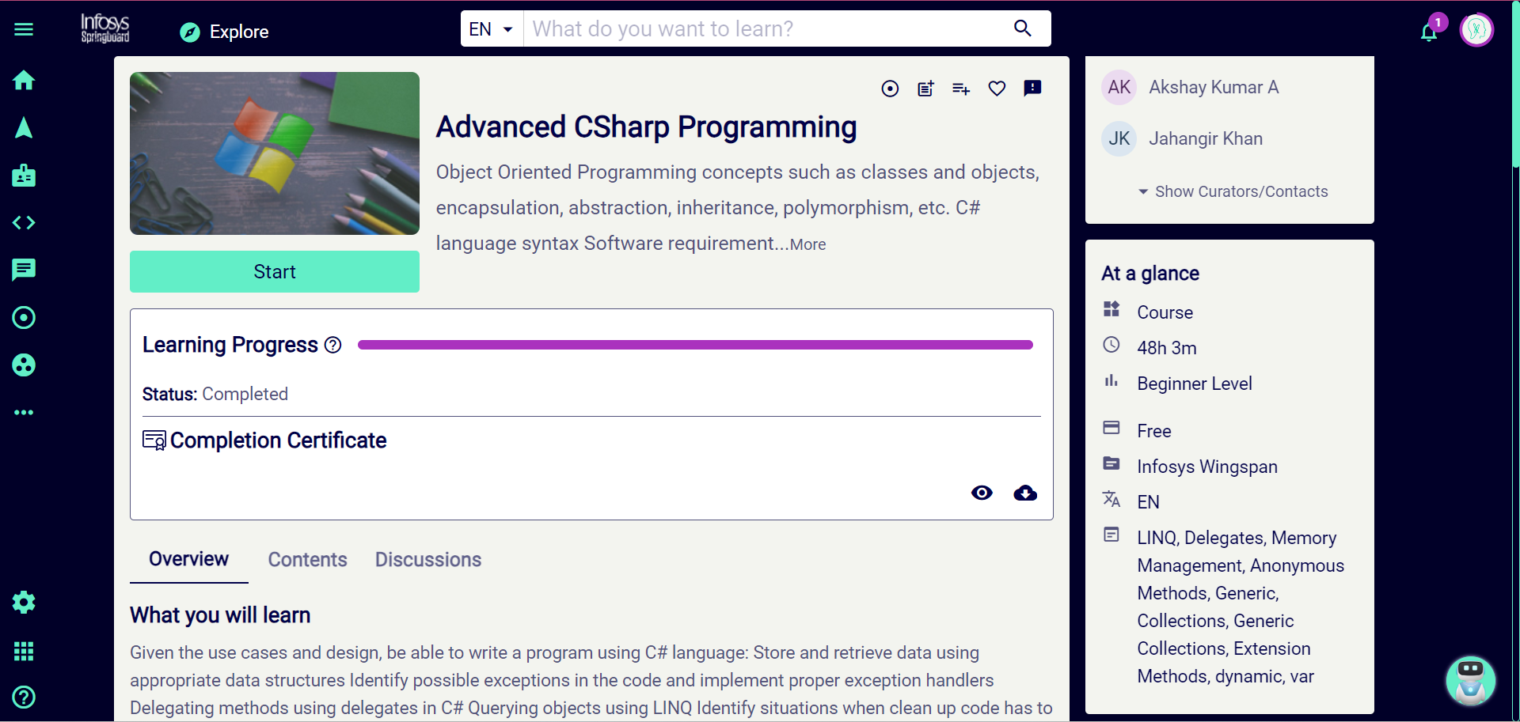

**15**



**SCORE AND PERFORMANCE REPORT**

* Advanced CSharp Programming
* Java Programming Fundamental
* Introduction to Python

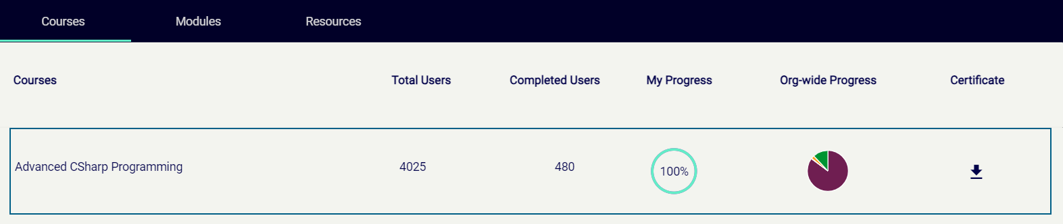





* EXCEL-R



**16**



**REFERENCES**

* <https://infyspringboard.onwingspan.com/web/en/login>
* <https://infyspringboard.onwingspan.com/web/en/app/toc/lex_auth_012664745277808640481_shared/overview>
* <https://infyspringboard.onwingspan.com/web/en/app/toc/lex_29959473947367270000_shared/overview>
* <https://infyspringboard.onwingspan.com/web/en/app/toc/lex_9339791338050886000_shared/overview>
* <https://onlinelearning.excelr.com/classrooms/7087/player?page=573923>
* <https://www.w3schools.com/java/>
* <https://www.javatpoint.com/advanced-c-sharp>
* <https://www.youtube.com/results?search_query=java+course>
* <https://www.youtube.com/results?search_query=java+course>
* <https://www.geeksforgeeks.org/how-to-read-excel-file-in-r/>

**17**



**PLAGIARISM REPORT**

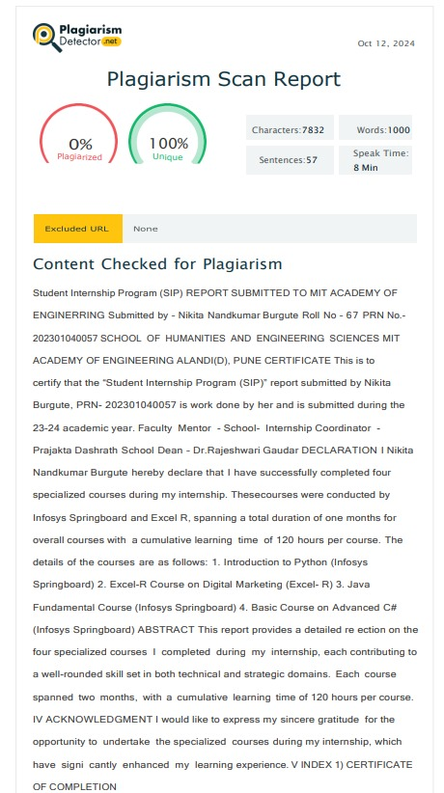

**18**